***Visoka škola strukovnih studija za informacione I***

***komunikacione tehnologije***

**Dokumentacija**

*(*[*https://mk-international.000webhostapp.com/*](https://mk-international.000webhostapp.com/)*)*

Student: Marko Šćekić

Smer: Internet Tehnologije (Web Programiranje)

Broj indeksa: 331/17

Predmet: Web Programiranje 2

**Sadržaj dokumentacije:**

1. **Uvod** __________________________________________________________________________03

1.1 Korišćeni programski jezici ________________________________________________03

1.2 Opis funkcionalnosti______________________________________________________ 03

2. **Organizacija i izgled** ________________________________________________________ 03

2.1 index.html_______________________________________________________________00

2.2 products.html___________________________________________________________00

2.3 contact.html ____________________________________________________________00

2.4 about.html _____________________________________________________________00

2.5 cart.html ________________________________________________________________00

3. **Kod** ____________________________________________________00

4. **SEO** ____________________________________________________00

**1. UVOD**

1.1 Korišćeni programski jezici

Za izradu sajta je korišćeno:

* CDN: CloudFlare, JSdeliver
* Framework: Bulma(CSS)
* API: ipify
* Libraries: jQuery, CryptoJS, JS-Cookie, SweeetAlert, FontAwesome

1.2 Opis funkcionalnosti I izgled

Sajt ime sledeće funkcionalnosti:

* ***Responsive***: potpuno je responsive, testirano na monitoru(24”), laptop( 15.6”) Imobilnom uređaju(6”)
* **Dark:** sajt je u tamnijim bojama radi lakseg 'web surfa' noću i u tamnijim prostorijama. Između 20h i 6h slika bulme je crna
* **Dinamički proizvodi**: proizvodi se inicijalno prikazuju u onom redu kako su upisivani u JSON, zatim se mogu filtrirati po veličini I boji. Kada korisnik izabere željeni proizvod, može ga dodati u korpu pritiskom na dugme “Add to cart”
* **Korpa**: proizvodi koje je korisnik ubacio u korpu se prikazuju na stranici cart.htm
* **Forma za kontakt**: nalaze se na strani Contact, odrađena je forma sa validacijom

Javascriptom (jQuery za pozivanje elemenata I sweetalert za obavestenja)

Izgled stranica

2. Organizacija i izgled

2.1 index.html

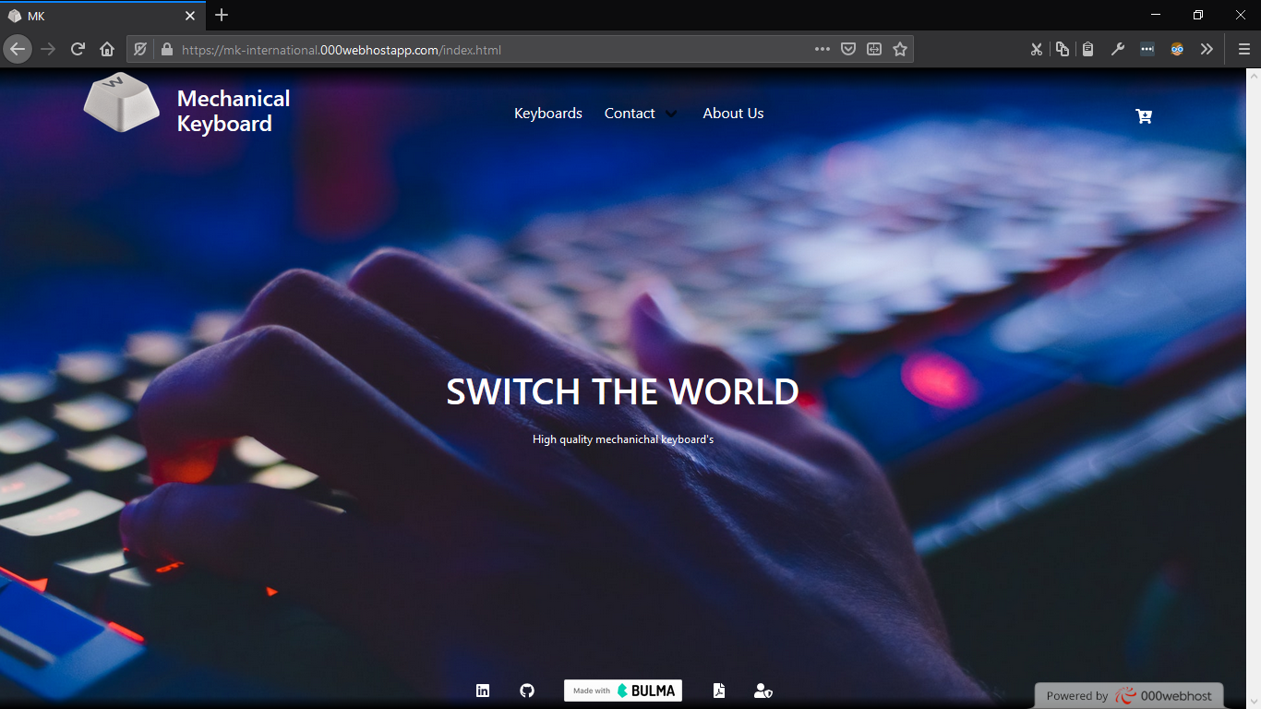

Do indeks stranice se dolazi klikom na ikonicu(beli taster)

index.html na mobilnom uređaju:

2.2 products.html

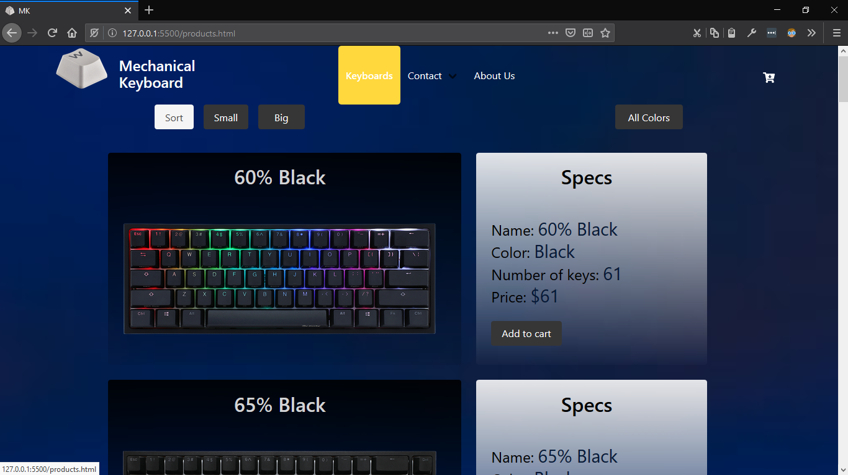Inicijalni izgled stranice *products.html* I prelaskom misa na *Keyboards* sa hover efektom.

Kada se pritisne dugme Add to cart , mala animacija se desi koja traje 0.7 sekundu I imesto teksta je stiklirana ikonica I pored slicice(FontAwesome) korpe pise broj proizvoda u korpi

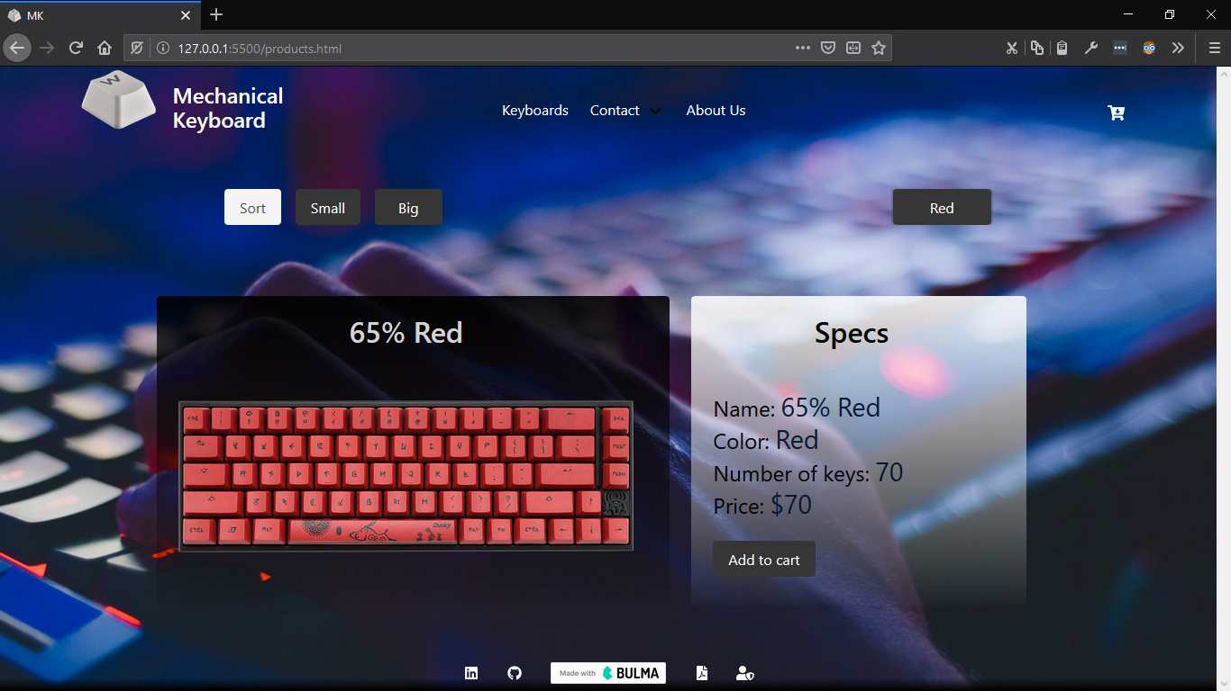Izgled stranice products.html kada se filtriraju tastature u boji crvena

2.3 contact.html

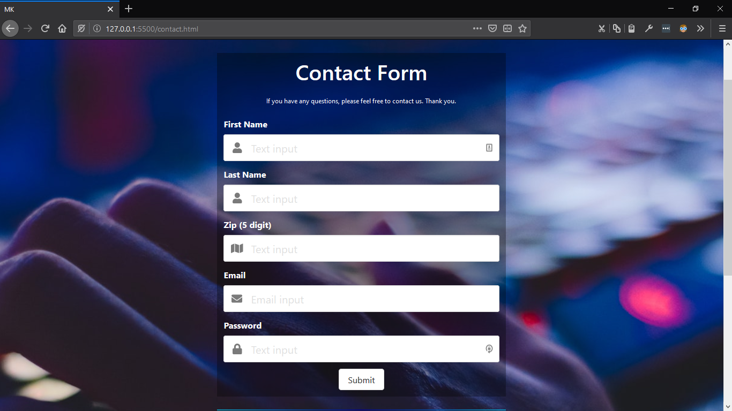

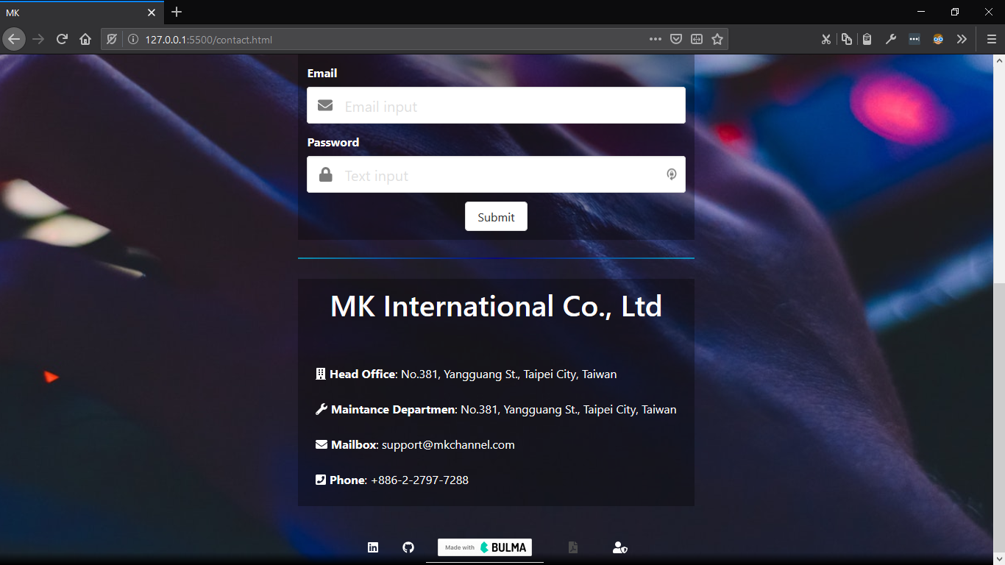

Inicijalni prikaz stranice contact.html

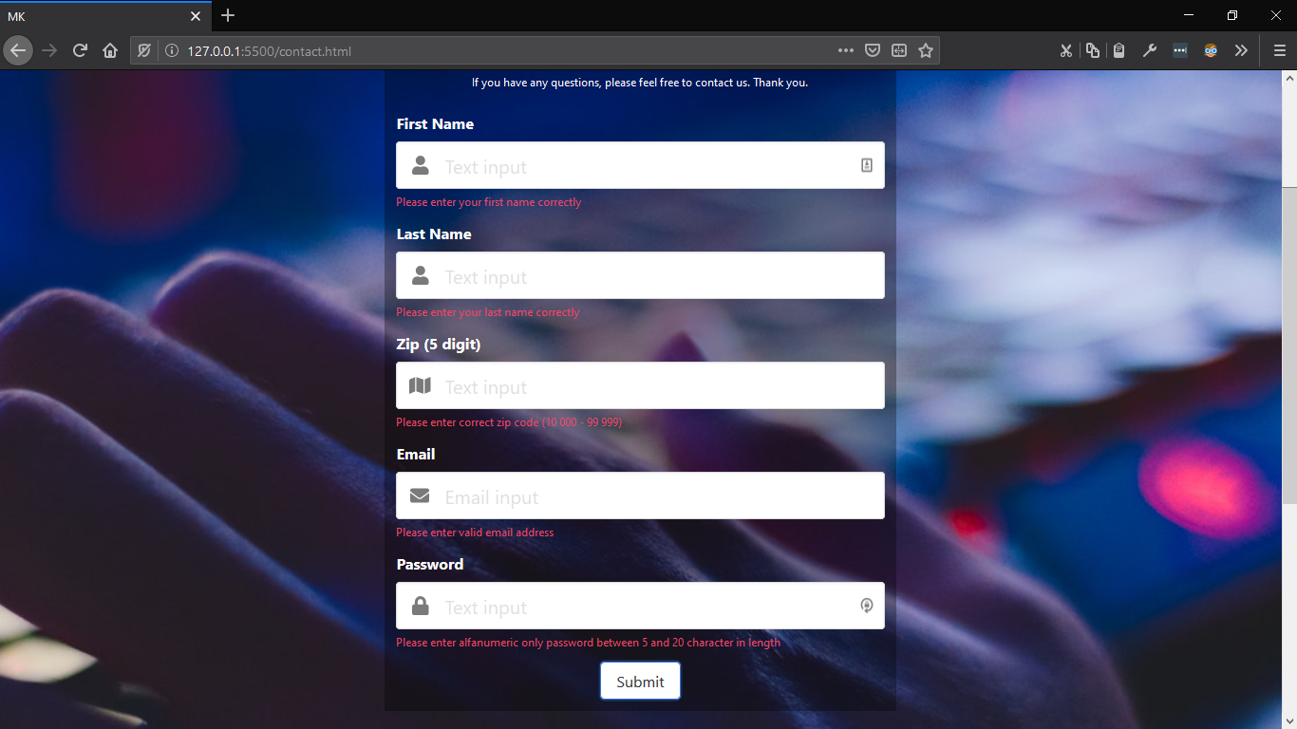 Izgled kada korsnik pogresno unese (sve) podatke

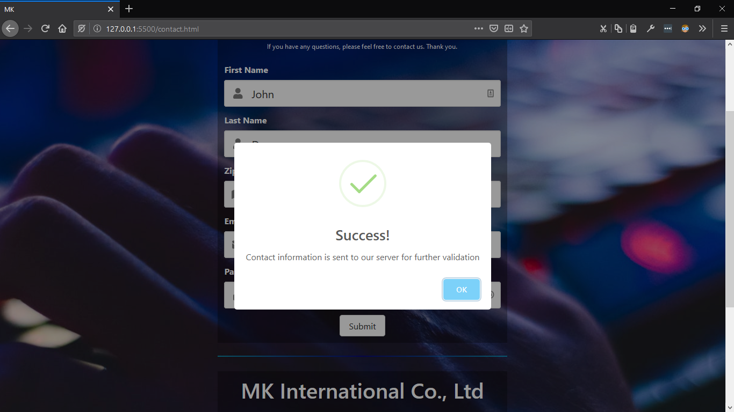 Izgled stranice Contact kada korisnik unese tacne podatke

2.5 cart.html

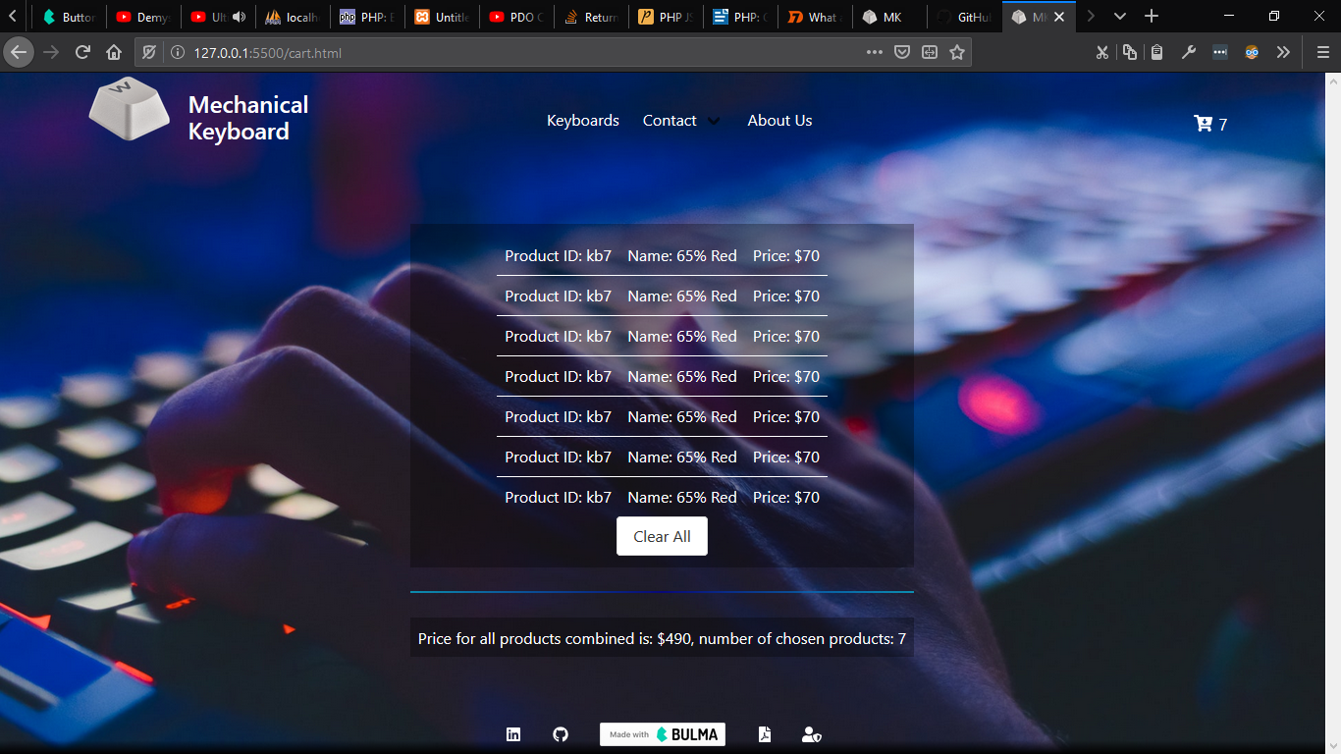 Prikaz stranice cart.html sa 7 proizvoda I ukupnom cenom svih proizvoda

3. Kod

3.1 HTML

3.1.1 index.html

<!DOCTYPE html>

<html lang="en">

<head> <meta charset="UTF-8">

    <meta name="viewport" content="width=device-width, initial-scale=1"><meta name="description" content="MK International is world renown for its excellent mechanical keyboards" />

    <title>MK</title>

    <link rel="shortcut icon" href="img/pbt-white.png" type="image/x-icon" /><link rel="stylesheet" href="css/bulma.css">

<link rel="stylesheet" href="css/helpers.css">

    <link rel="stylesheet" href="css/grid.css">

    <link rel="stylesheet" href="css/style.css">

    <link type="text/css" href="bulma-social.min.css">

    <link rel="stylesheet" href="https://cdnjs.cloudflare.com/ajax/libs/font-awesome/4.7.0/css/font-awesome.css">

</head><style>.hero {

*background*: url(*img/homepageMK.jpg*) center/cover;

}  @media (*max-width*: 900px) {

.hero {*background*: url(*img/homepageMK.jpg*) center/cover;

 }  }@media (*max-width*: 420px) {

.hero {*background*: url(*img/homepageMK-small.jpg*) center/cover;

 #mkSwitchH1 {*font-size*: small;

*font-weight*: 800;}

#mkSwitch {*width*: 50px;*height*: 50px;}</style><body> <section class="hero  is-fullheight">

        <header><nav class="navbar is-warning" id="navBoja" role="navigation" aria-label="Main navigation">

                <div class="container">

                    <div class="navbar-brand is-tablet ">

                        <a href="index.html"><img src="img/pbt-white.png" id='mkSwitch' width="90" height="20"></a>

                        <p class="title is-4 navPBrand" style="color:white">Mechanical<br>Keyboard</p>

                        <div class="navbar-burger" data-target="navbar">

                            <span style="color:white"></span>

                            <span style="color:white"></span>

                            <span style="color:white"></span>

                        </div></div>

                    <div class="navbar-menu navBarAnchor" id="navbar" style="margin-left: 20%;">

                        <div class="navbar-start">

                            <div class="navbar-item AboutHover">

                                <a href="products.html"> <p>Keyboards</p>

                                </a></div>

                            <div class="navbar-item has-dropdown is-hoverable AboutHover "><a href="contact.html" class="navbar-link aPreventDefault">

                                    <p>Contact</p></a>

                                <ul class="navbar-dropdown is-boxed">

                                    <a href="contact.html" class="navbar-item burgerColor">Form</a><a href="contact.html#a" class="navbar-item burgerColor">Info</a></ul></div>

                            <div class="navbar-item AboutHover">

                                <a href="about.html">p>About Us</p>

                                </a> </div></div><div class="navbar-end">

                            <div class="buttons has-addons cart">

                                <a href="cart.html" id="cartAncher" class="navbar-item has-text-white"> <span class="icon is-medium"><i class="fa fa-cart-arrow-down"></i>

                                    </span></a></div></div></div></nav>

        </header><main class="hero-body center" style="padding: 2rem;">

<div id="grid" style="width: 768px;">

<div id="a" class="center-column has-text-centered subtitle">

                    <h2 class="title is-2 white ">SWITCH THE WORLD</h2><br>

                    <p class='content is-small'>High quality mechanichal keyboard's</p></div></div></main>

<div class="hero-foot" id="footerBoja">

            <nav class="tabs">

                <div class="container center-column white">

                    <ul><li><span class="icon is-medium">

                                <i class="fab fa-linkedin"></i>

                                <span> </li> <li>

                            <span class="icon is-medium ">

                                <i class="fab fa-github"></i></span></li><li>

                            <a id="bulma" href="https://bulma.io">

                            </a></li><li> <span class="icon is-medium">

                                <i class="fas fa-file-pdf"></i></span></li><li>

                            <span class="icon is-medium">

                                <i class="fas fa-user-shield"></i>

                            </span></li></ul></div> </nav></div></section>

<script src="https://cdn.jsdelivr.net/combine/npm/jquery@3.4.1/dist/jquery.min.js"></script>

    <script src="https://cdn.jsdelivr.net/npm/js-cookie@beta/dist/js.cookie.min.js"></script>

    <script src="https://use.fontawesome.com/releases/v5.1.0/js/all.js"></script>

    <script src="https://cdnjs.cloudflare.com/ajax/libs/crypto-js/3.1.2/rollups/aes.js"></script>

<script type="text/javascript" src="js/script.js"></script>

</body></html>

3.1.2 products.html

<!DOCTYPE html>

<html lang="en"><head>

    <meta charset="UTF-8">

    <meta name="viewport" content="width=device-width, initial-scale=1">

    <meta name="description" content="MK International is world renown for its excellent mechanical keyboards" />

    <title>MK</title>

    <link rel="shortcut icon" href="img/pbt-white.png" id="ikonica" type="image/x-icon" />

    <link rel="stylesheet" href="css/bulma.css">

<link rel="stylesheet" href="/css/helpers.css">

    <link rel="stylesheet" href="/css/grid.css">

    <link rel="stylesheet" href="/css/style.css">

    <link rel="stylesheet" href="/css/bulma-social.min.css">

    <link rel="stylesheet" href="https://cdnjs.cloudflare.com/ajax/libs/font-awesome/4.7.0/css/font-awesome.css">

</head><style>.hero {

*background*: url(*img/homepageMK.jpg*) center/cover;

}@media (*max-width*: 900px) {

 .hero { *background*: url(*img/homepageMK.jpg*) center/cover;}}

@media (*max-width*: 420px) {.hero {

*background*: url(*img/homepageMK-small.jpg*) center/cover;

} #mkSwitchH1 {

*font-size*: small;

*font-weight*: 800;

}#mkSwitch {

*width*: 50px;

*height*: 50px;}}

</style><body><section class="hero  is-fullheight">

        <header><nav class="navbar is-warning" id="navBoja" role="navigation" aria-label="Main navigation">

                <div class="container"><div class="navbar-brand is-tablet ">

                        <a href="index.html"><img src="img/pbt-white.png" id='mkSwitch' width="90" height="20"></a>

                        <p class="title is-4 navPBrand" style="color:white">Mechanical<br>Keyboard</p>

                        <div class="navbar-burger" data-target="navbar">

 <span style="color:white"></span>

       <span style="color:white"></span>

                            <span style="color:white"></span>

                        </div> </div>

                    <div class="navbar-menu navBarAnchor" id="navbar" style="margin-left: 20%;">

                        <div class="navbar-start">

                            <div class="navbar-item AboutHover">

             <a href="products.html"><p>Keyboards</p></a> </div>

                            <div class="navbar-item has-dropdown is-hoverable AboutHover "><a href="contact.html" class="navbar-link aPreventDefault"><p>Contact</p></a><ul class="navbar-dropdown is-boxed">

                    <a href="contact.html" class="navbar-item burgerColor">Form</a><a href="contact.html#a" class="navbar-item burgerColor">Info</a></ul>  </div> <div class="navbar-item AboutHover">

                                <a href="about.html">  <p>About Us</p></a>  </div>   </div>

<div class="navbar-end"><div class="buttons has-addons cart">

                                <a href="cart.html" id="cartAncher" class="navbar-item has-text-white">

                                    <span class="icon is-medium"><i class="fa fa-cart-arrow-down"></i>

                                    </span></a>   </div></div></div></div></nav></header>

 <div class="tabs is-centered is-large "> <ul> <li class=" is-big" style="margin-right: 1rem;"> <span class="button is-light">Sort </span></li> <li class=" is-big"><span class="button  is-dark " id="smallKeyboardFirst">Small</span></li>

                <li class=" is-big" style="margin-left: 1rem;"><span class="button  is-dark"

                        id="bigKeyboardFirst">Big</span></li></ul>  <ul> <li class="is-big">

                    <select class="has-dropdown button  is-dark" id="clickSelectColor"><option value="" class="selectColor">All Colors</option><option value="Red" class="selectColor"> Red</option>

                        <option value="Black" class="selectColor"> Black</option><option value="Blue" class="selectColor"> Blue</option>

                        <option value="White" class="selectColor"> White</option><option value="Grey" class="selectColor">Grey</option>

                        <option value="Brown" class="selectColor">Brown</option>

                        <option value="Pink" class="selectColor">Pink</option>

                    </select> </li></ul></div> <main class="" id='keyboardHtml' style="padding:0.1rem;">

</main><div class="hero-foot" id="footerBoja"> <nav class="tabs"> <div class="container center-column white"> <ul><li><span class="icon is-medium"> <i class="fab fa-linkedin"></i><span>  </li>  <li><span class="icon is-medium ">

                                <i class="fab fa-github"></i>  </span> </li><li><a id="bulma" href="https://bulma.io">

                            </a>  </li><li><span class="icon is-medium"> <i class="fas fa-file-pdf"></i></span>  </li> <li>

                            <span class="icon is-medium"> <i class="fas fa-user-shield"></i></span></li> </ul>  </div></nav></div></section>

<script src="https://cdn.jsdelivr.net/combine/npm/jquery@3.4.1/dist/jquery.min.js"></script>

    <script src="https://cdn.jsdelivr.net/npm/js-cookie@beta/dist/js.cookie.min.js"></script>

    <script src="https://use.fontawesome.com/releases/v5.1.0/js/all.js"></script>

    <script src="https://cdnjs.cloudflare.com/ajax/libs/crypto-js/3.1.2/rollups/aes.js"></script>

    <script type="text/javascript" src="js/script.js"></script>/body></html>

333.

3.1.3 contact.html

<!DOCTYPE html>

<html lang="en">

<head>

  <meta charset="UTF-8">

  <meta name="viewport" content="width=device-width, initial-scale=1">

  <meta name="description" content="MK International is world renown for its excellent mechanical keyboards" />

  <title>MK</title>

  <link rel="shortcut icon" href="img/pbt-white.png" id="ikonica" type="image/x-icon" />

  <link rel="stylesheet" href="css/bulma.css">

<link rel="stylesheet" href="/css/helpers.css">

  <link rel="stylesheet" href="/css/grid.css">

  <link rel="stylesheet" href="/css/style.css">

  <link rel="stylesheet" href="/css/bulma-social.min.css">

  <link rel="stylesheet" href="https://cdnjs.cloudflare.com/ajax/libs/font-awesome/4.7.0/css/font-awesome.css">

</head><style>

  .hero {*background*: url(*img/homepageMK.jpg*) center/cover;

}@media (*max-width*: 900px) {

    .hero { *background*: url(*img/homepageMK.jpg*) center/cover;

}}@media (*max-width*: 420px) {

    .hero { *background*: url(*img/homepageMK-small.jpg*) center/cover;

}}</style><body>

<section class="hero  is-fullheight">

    <header><nav class="navbar is-warning" id="navBoja" role="navigation" aria-label="Main navigation">

        <div class="container"><div class="navbar-brand is-tablet ">

            <a href="index.html"><img src="img/pbt-white.png" id='mkSwitch' width="90" height="20"></a>

            <p class="title is-4 navPBrand" style="color:white">Mechanical<br>Keyboard</p>

            <div class="navbar-burger" data-target="navbar">

              <span style="color:white"></span>

              <span style="color:white"></span>

              <span style="color:white"></span>

            </div> </div>

          <div class="navbar-menu navBarAnchor" id="navbar" style="margin-left: 20%;">

            <div class="navbar-start">

              <div class="navbar-item AboutHover">

                <a href="products.html">

                  <p>Keyboards</p></a> </div>

              <div class="navbar-item has-dropdown is-hoverable AboutHover "><a href="contact.html" class="navbar-link aPreventDefault"> <p>Contact</p>

                </a>

                <ul class="navbar-dropdown is-boxed">

                  <a href="contact.html" class="navbar-item burgerColor">Form</a><a href="contact.html#a" class="navbar-item burgerColor">Info</a>/ul></div><div class="navbar-item AboutHover">

                <a href="about.html">

                  <p>About Us</p>

                </a> </div></div>

            <div class="navbar-end">

              <div class="buttons has-addons cart">

                <a href="cart.html" id="cartAncher" class="navbar-item has-text-white"><span class="icon is-medium">

                    <i class="fa fa-cart-arrow-down"></i>

                  </span></a></div></div></div>

        </div> </nav> </header>

    <main class="hero-foot  center is-desktop" style="padding: 2rem;"><main class="hero-foot is-mobile-only" style="max-width:99%;">

 <div class="column abcd ">

          <div class="center-column has-text-centered subtitle">

            <h2 class="title is-2 white ">Contact Form</h2>

            <p class='content is-small'>If you have any questions, please feel free to contact us. Thank you.</p>

          </div><form method="post" id="contactForm">

<div class="field"><label class="label has-text-white">First Name</label> <div class="control has-icons-left has-icons-right">

                <input class="input is-medium" id="fname" type="text" placeholder="Text input" value="">

                <!-- class="input is-danger" -->

                <span class="icon is-small is-left has-text-grey">

                  <i class="fas fa-user"></i>

                </span></div>

              <p class="help is-danger ContactError" id="fnameError"></p></div><div class="field">

              <label class="label has-text-white">Last Name</label>

              <div class="control has-icons-left has-icons-right">

                <input class="input is-medium" id="lname" type="text" placeholder="Text input" value="">

                <!-- class="input is-danger" -->

                <span class="icon is-small is-left has-text-grey">

                  <i class="fas fa-user"></i>

                </span></div><p class="help is-danger ContactError" id="lnameError"></p></div>

            <div class="field">

              <label class="label has-text-white">Zip (5 digit)</label><div class="control has-icons-left has-icons-right">

                <input class="input is-medium" id="zip" type="text" placeholder="Text input" value=""><span class="icon is-small is-left has-text-grey">

                  <i class="fa fa-map" aria-hidden="true"></i>

                </span> </div>

              <p class="help is-danger" id="zipError"></p>

            </div><div class="field">

              <label class="label has-text-white">Email</label>

              <div class="control has-icons-left has-icons-right">

                <input class="input is-medium" id="email" type="email" placeholder="Email input" value="">

                <!-- class="input is-danger" -->

                <span class="icon is-small is-left has-text-grey">

                  <i class="fas fa-envelope"></i>

                </span><span class="icon is-small is-right">

               </span></div>

              <p class="help is-danger ContactError" id="emailError"></p>

            </div><div class="field">

              <label class="label has-text-white">Password</label>

              <div class="control has-icons-left has-icons-right">

                <input class="input is-medium " id="pass" type="password" placeholder="Text input" value="">

                <!-- class="input is-danger" -->

                <span class="icon is-small is-left has-text-grey">

                  <i class="fas fa-lock"></i>

                </span> </div>

              <p class="help is-danger ContactError" id="passError"></p></div> <div class="field">

              <div class="control center-column">

                <input type="submit" class="button" id="submitInfo" is-info" value="Submit">

                <!-- <button class="button is-link">Help</button> -->

              </div></div>

          </form>

        </div><hr class="devider"

          style="background: linear-gradient(90deg, rgba(0,212,255,0.6110644086990165) 0%, rgba(9,9,121,1) 50%, rgba(0,212,255,0.61) 100%);"> <div class="column abcd" style="margin-top:5%">

          <div id="a" class="center-column has-text-centered subtitle"><h2 class="title is-2 white">MK International Co., Ltd</h2> <br></div>

          <ul> <li style="padding: 0.75rem;">

              <p><i class="fas fa-building "></i><span class="has-text-weight-bold"> Head Office</span>: No.381,

                Yangguang St., Taipei City, Taiwan </p>

            </li>

            <li style="padding: 0.75rem;">

              <p> <i class="fas fa-wrench"></i><span class="has-text-weight-bold"> Maintance Departmen</span>: No.381,

                Yangguang St., Taipei City, Taiwan </p>

            </li> <li style="padding: 0.75rem;">

              <p> <i class="fa fa-envelope"></i><span class="has-text-weight-bold"> Mailbox</span>:

                support@mkchannel.com</p>

            </li><li style="padding: 0.75rem;">

              <p><i class="fa fa-phone-square is-danger"></i><span class="has-text-weight-bold"> Phone</span>:

                +886-2-2797-7288 </p>

            </li></ul>

        </div></main>

    </main> <div class="hero-foot" id="footerBoja">

      <nav class="tabs">

        <div class="container center-column white">

          <ul> <li>

              <span class="icon is-medium">

                <i class="fab fa-linkedin"></i>

                <span></li><li>

              <span class="icon is-medium ">

                <i class="fab fa-github"></i>

              </span></li><li>

              <a id="bulma" href="https://bulma.io">

              </a></li><li>  <a href="documentatio.docx">

                <span class="icon is-medium">

                  <i class="fas fa-file-pdf"></i>

                </span></a>  </li><li>

              <span class="icon is-medium">

                <i class="fas fa-user-shield"></i>

              </span>

            </li></ul></div> </nav></div></section>

<script src="https://cdn.jsdelivr.net/combine/npm/jquery@3.4.1/dist/jquery.min.js"></script>

  <script src="https://cdn.jsdelivr.net/npm/js-cookie@beta/dist/js.cookie.min.js"></script>

  <script src="https://use.fontawesome.com/releases/v5.1.0/js/all.js"></script>

  <script src="https://cdnjs.cloudflare.com/ajax/libs/crypto-js/3.1.2/rollups/aes.js"></script>

  <script src="https://cdn.jsdelivr.net/npm/sweetalert"></script>

  <script type="text/javascript" src="js/script.js"></script>

</body></html>

3.1.4 about.html

<!DOCTYPE html><html lang="en"><head>

    <meta charset="UTF-8">

    <meta name="viewport" content="width=device-width, initial-scale=1">

    <meta name="description" content="MK International is world renown for its excellent mechanical keyboards" />

    <title>MK</title> <link rel="shortcut icon" href="img/pbt-white.png" id="ikonica" type="image/x-icon" />

    <link rel="stylesheet" href="css/bulma.css">

<link rel="stylesheet" href="/css/helpers.css">

    <link rel="stylesheet" href="/css/grid.css">

    <link rel="stylesheet" href="/css/style.css">

    <link rel="stylesheet" href="/css/bulma-social.min.css">

    <link rel="stylesheet" href="https://cdnjs.cloudflare.com/ajax/libs/font-awesome/4.7.0/css/font-awesome.css">

</head>

<style>.hero {*background*: url(*img/homepageMK.jpg*) center/cover;

} @media (*max-width*: 900px) {

    .hero{*background*: url(*img/homepageMK.jpg*) center/cover;

}}@media (*max-width*: 420px) {

    .hero {*background*: url(*img/homepageMK-small.jpg*) center/cover;

}}</style><body><section class="hero  is-fullheight">

    <header><nav class="navbar is-warning" id="navBoja" role="navigation" aria-label="Main navigation">

        <div class="container">

          <div class="navbar-brand is-tablet ">

            <a href="index.html"><img src="img/pbt-white.png" id='mkSwitch' width="90" height="20"></a>

            <p class="title is-4 navPBrand" style="color:white">Mechanical<br>Keyboard</p>

            <div class="navbar-burger" data-target="navbar">

              <span style="color:white"></span>

              <span style="color:white"></span>

              <span style="color:white"></span>

            </div> </div>

          <div class="navbar-menu navBarAnchor" id="navbar" style="margin-left: 20%;">

            <div class="navbar-start">

              <div class="navbar-item AboutHover">

                <a href="products.html">

                  <p>Keyboards</p>

                </a></div>

              <div class="navbar-item has-dropdown is-hoverable AboutHover "><a href="contact.html" class="navbar-link aPreventDefault"> <p>Contact</p>

                </a><ul class="navbar-dropdown is-boxed">

                  <a href="contact.html" class="navbar-item burgerColor">Form</a><a href="contact.html#a" class="navbar-item burgerColor">Info</a></ul>

              </div>

              <div class="navbar-item AboutHover">

                <a href="about.html">

                  <p>About Us</p>

                </a></div></div>

            <div class="navbar-end">

              <div class="buttons has-addons cart">

                <a href="cart.html" id="cartAncher" class="navbar-item has-text-white">

                  <span class="icon is-medium">

                    <i class="fa fa-cart-arrow-down"></i>

                  </span></a>

              </div></div></div></div>

 </nav></header><main class="hero-foot  center is-desktop aboutDesktopWidth" style="padding: 2rem;">

      <main class="hero-foot is-mobile-only" style="max-width:99%;">

        <div class="center-column has-text-centered subtitle centerBlack" >h2 class="title is-2 white "> About MK</h2>

<p class="content is-medium aboutText" >Based in Taiwan, MK founded its own brand in 2008 and became a manufacturing company that

            has strived to provide users with mechanical keyboards of the highest standard since day one. Fast forward

            to now, we are one of the top mechanical keyboard manufacturers in the world and have built a reputation for

            providing products that are innovative, performance oriented and solidly built. Our ultimate goal is to have

            our logo be synonymous with excellence and product satisfaction. Having already established business partnerships in over 30 countries, MK has made a name for ourselves

            globally. We are eager to continue expanding, giving consumers in every corner of the world a channel to

            purchase and experience MK products.  Moving forward, we will be aiming to reach even greater heights, tirelessly figuring out ways to come up

            with products that help users optimize their typing experience. Whether you're working or playing, give your

            fingers the comfort they deserve.</p>

        </div> <hr class="devider"

          style="background: linear-gradient(90deg, rgba(0,212,255,0.6110644086990165) 0%, rgba(9,9,121,1) 50%, rgba(0,212,255,0.61) 100%);"><div class="center-column abcd" id="autor" style="margin-top:5%"><h3 class="title center is-3 whiteText">Author</h3><br>

          <div class="tiles center ">

            <div class="tile is-15 ">

           <div class="tile is-parent is-8 ">

                <article class="tile is-child ">

<ul><li><p class="subtitle is-4 whiteText">Marko Scekic</p></li></ul><ul><li><p class="subtitle is-4 whiteText">Broj Indeksa: <span class=""> 331/17<span></p>

                    </li></ul>

                  <ul><li><p class="subtitle is-4 whiteText">This website is built for school course 'Web Programiranje 2'

                      </p> </li> </ul> </article>

              </div> </div> </div> </div> </main> </main>

  <div class="hero-foot" id="footerBoja">

      <nav class="tabs">

        <div class="container center-column white">

          <ul>  <li> <span class="icon is-medium">

                <i class="fab fa-linkedin"></i>

                <span> </li> <li>

              <span class="icon is-medium ">

                <i class="fab fa-github"></i>

              </span> </li> <li>

              <a id="bulma" href="https://bulma.io">

              </a> </li> <li> <span class="icon is-medium">

                <i class="fas fa-file-pdf"> </i>  </span>

            </li> <li><span class="icon is-medium">

                <i class="fas fa-user-shield"></i>

         </span> </li> </ul> </div> </nav>

    </div> </section><script src="https://cdn.jsdelivr.net/combine/npm/jquery@3.4.1/dist/jquery.min.js"></script>

  <script src="https://cdn.jsdelivr.net/npm/js-cookie@beta/dist/js.cookie.min.js"></script>

  <script src="https://use.fontawesome.com/releases/v5.1.0/js/all.js"></script>

  <script src="https://cdnjs.cloudflare.com/ajax/libs/crypto-js/3.1.2/rollups/aes.js"></script>

  <script type="text/javascript" src="js/script.js"></script>

</body></html>

3.1.4 cart.html

<!DOCTYPE html>

<html lang="en"><head>

    <meta charset="UTF-8">

    <meta name="viewport" content="width=device-width, initial-scale=1"><meta name="description" content="MK International is world renown for its excellent mechanical keyboards" />

    <title>MK</title>  <link rel="shortcut icon" href="img/pbt-white.png" id="ikonica" type="image/x-icon" /><link rel="stylesheet" href="css/bulma.css">

<link rel="stylesheet" href="/css/helpers.css">

    <link rel="stylesheet" href="/css/grid.css">

    <link rel="stylesheet" href="/css/style.css">

    <link rel="stylesheet" href="/css/bulma-social.min.css">

    <link rel="stylesheet" href="https://cdnjs.cloudflare.com/ajax/libs/font-awesome/4.7.0/css/font-awesome.css">

</head><style>.hero { *background*: url(*img/homepageMK.jpg*) center/cover;}@media (*max-width*: 900px) {

    .hero {*background*: url(*img/homepageMK.jpg*) center/cover;

}}@media (*max-width*: 420px) { .hero {

*background*: url(*img/homepageMK-small.jpg*) center/cover;

 } }</style><body><section class="hero  is-fullheight">

    <header>

      <nav class="navbar is-warning" id="navBoja" role="navigation" aria-label="Main navigation">

        <div class="container">

          <div class="navbar-brand is-tablet ">

            <a href="index.html"><img src="img/pbt-white.png" id='mkSwitch' width="90" height="20"></a>

            <p class="title is-4 navPBrand" style="color:white">Mechanical<br>Keyboard</p>

            <div class="navbar-burger" data-target="navbar">

              <span style="color:white"></span>

              <span style="color:white"></span>

              <span style="color:white"></span> </div></div>

          <div class="navbar-menu navBarAnchor" id="navbar" style="margin-left: 20%;"> <div class="navbar-start">

              <div class="navbar-item AboutHover">

                <a href="products.html">

                  <p>Keyboards</p>  </a></div>

              <div class="navbar-item has-dropdown is-hoverable AboutHover "> <a href="contact.html" class="navbar-link aPreventDefault">

                  <p>Contact</p></a>

                <ul class="navbar-dropdown is-boxed">

                  <a href="contact.html" class="navbar-item burgerColor">Form</a><a href="contact.html#a" class="navbar-item burgerColor">Info</a></ul></div>

              <div class="navbar-item AboutHover">

                <a href="about.html"><p>About Us</p></a></div>  </div>

            <div class="navbar-end">

              <div class="buttons has-addons cart">

                <a href="cart.html" id="cartAncher" class="navbar-item has-text-white"> <span class="icon is-medium">

                    <i class="fa fa-cart-arrow-down"></i>

                  </span></a></div> </div> </div> </div></nav></header>

    <main class="hero-foot  center is-desktop" style="padding: 2rem;"><main class="hero-foot is-mobile-only" style="max-width:99%;">

 <div class="column abcd" id="localStorageCart">

 <h2>Cart is empty</h2></div> <hr class="devider">

        <div class="column abcd" id="priceCart" style="margin-top:5%">

</div>  </main></main> <div class="hero-foot" id="footerBoja">

      <nav class="tabs">

        <div class="container center-column white">

          <ul> <li> <span class="icon is-medium">

                <i class="fab fa-linkedin"></i>

                <span>  </li> <li> <span class="icon is-medium ">

                <i class="fab fa-github"></i> </span>

            </li> <li>  <a id="bulma" href="https://bulma.io">

              </a> </li> <li> <span class="icon is-medium">

                <i class="fas fa-file-pdf"></i></span>

            </li> <li><span class="icon is-medium">

                <i class="fas fa-user-shield"></i>

              </span></li> </ul> </div></nav></div>

  </section><script src="https://cdn.jsdelivr.net/combine/npm/jquery@3.4.1/dist/jquery.min.js"></script>

  <script src="https://cdn.jsdelivr.net/npm/js-cookie@beta/dist/js.cookie.min.js"></script>

  <script src="https://use.fontawesome.com/releases/v5.1.0/js/all.js"></script><script src="https://cdnjs.cloudflare.com/ajax/libs/crypto-js/3.1.2/rollups/aes.js"></script>

  <script type="text/javascript" src="js/script.js"></script>

</body></html>

3

3.2 CSS

/bulma-socila.min.css

/bulma.css

/debug.css

/grid.css

/helpers.css

3.2.1 style.css

.hero {

*background*: url(*img/homepageMK.jpg*) center/cover;

}.keyboardPositioning {

*margin-left*: 12%;

}@media (*max-width*: 900px) {

    .hero {

*background*: url(*img/homepageMK.jpg*) center/cover;

} .keyboardPositioning {

*margin-left*: 12%;

    }.aboutText {

*width*: 80%;

    }}

@media (*max-width*: 800px) {

    .hero { *background*: url(*img/homepageMK.jpg*) center/cover;

}.keyboardPositioning {

*margin-left*: 8%;}

.aboutText {*width*: 95%;}

@media (*max-width*: 420px) {

    .hero {*background*: url(*img/homepageMK-small.jpg*) center/cover;

}.keyboardPositioning {

*margin-left*: 0%;}

.aboutText {

*width*: 100%;

    }.abcd {

*background-color*: rgba(0, 0, 0, 0.315);

}.andmsa {

*background-color*: rgba(10, 10, 10, 0.09);

}.navPBrand {

    /* font-size: larger; */

*margin-top*: 17px;

*margin-left*: 15px;

}AboutHover:hover {

*background-color*: #ffd83d;

*border-radius*: 5px;

*color*: grey;

*font-weight*: 600;

}#cartAncher p {

*font-size*: 17px;

}#cartAncher span {

*font-size*: 17px;

}cartAncher span:hover {

*background-color*: #ffd83d;

}.aPreventDefault {

*border-radius*: 15px;

}.aPreventDefault:hover {

*border-radius*: 5px;

*color*: silver;

*background-color*: #ffd83d;

}#navBoja {

*background*: rgb(0, 0, 0);

*background*: -moz-linear-gradient(180deg, rgba(0, 0, 0, 1) 0%, rgba(255, 255, 255, 0) 25%);

*background*: -webkit-linear-gradient(180deg, rgba(0, 0, 0, 1) 0%, rgba(255, 255, 255, 0) 25%);

*background*: linear-gradient(180deg, rgba(0, 0, 0, 1) 0%, rgba(255, 255, 255, 0) 25%);

}#footerBoja {

*background*: rgb(0, 0, 0);

*background*: -moz-linear-gradient(0deg, rgba(0, 0, 0, 1) 0%, rgba(255, 255, 255, 0) 35%);

*background*: -webkit-linear-gradient(0deg, rgba(0, 0, 0, 1) 0%, rgba(255, 255, 255, 0) 35%);

*background*: linear-gradient(0deg, rgba(0, 0, 0, 1) 0%, rgba(255, 255, 255, 0) 35%);

}body p,

h2,.white {

*color*: white;

}#wrapper {

*padding-top*: 1.5rem;

*padding-bottom*: 2rem;

}#colorFilterDiv {

*border*: 2px solid red;

}.navbarSort {

*margin-bottom*: 1rem;

}bigKeyboardFirst {

*padding-left*: 25px;*padding-right*: 25px;

}#cartAncher:hover,

#cartAncher span:hover {

*background-color*: rgba(153, 153, 153, 0);

*color*: #ffd83d;

}#localStorageCart table tr td,

#priceCart {

*color*: white;*padding*: 0.5rem;

}#saved {

*color*: white;

}#submitInfo {

*border-radius*: 5px;

}table tr {

*border-bottom*: 1px solid white;}

.whiteText {

*color*: white;}

.whiteText span {

*color*: rgb(255, 255, 130);}

.productText {

*background*: linear-gradient(0deg, rgba(243, 245, 245, 0.02) 0%, rgb(250, 250, 250, 0.9) 100%);

 }.productText ul {

*color*: rgb(0, 0, 0);

}.productTextH3 {

*color*: rgb(236, 10, 10);

}.productTextSpan {

*color*: rgba(2, 21, 51, 0.965);*font-size*: larger;

}.productPic {

*background*: linear-gradient(0deg, rgba(0, 0, 0, 0.062) 0%, rgba(0, 0, 0, 0.9) 100%);

*color*: rgba(248, 248, 248, 0.849);

}.devider {

*background*: linear-gradient(90deg, rgba(0, 212, 255, 0.6110644086990165) 0%, rgba(9, 9, 121, 1) 50%, rgba(0, 212, 255, 0.61) 100%);

}.centerBlack {

*background-color*: #03030336;

}.aboutText {

*max-width*: 70%;

}

3.3 JSON

/data/products.json

[{

*"product"*:"keyboard",

*"id"*:"kb1",

*"name"* : "60% Black",

*"numKeys"*:61,

*"color"*: "Black",

*"pic"*:"img/keyboards/60.png"

    },{

*"product"*:"keyboard",

*"id"*:"kb2",

*"name"* : "65% Black",

*"numKeys"*: 70,

*"color"*: "Black",

*"pic"*:"img/keyboards/65.png"

    },{

*"product"*:"keyboard",

*"id"*:"kb3",

*"name"* : "80% Black",

*"numKeys"*: 87,

*"color"*: "Black",

*"pic"*:"img/keyboards/87.png"

    },{

*"product"*:"keyboard",

*"id"*:"kb4",

*"name"* : "100% Black",

*"numKeys"*:104,

*"color"*: "Black",

*"pic"*:"img/keyboards/104.png"

    },{

*"product"*:"keyboard",

*"id"*:"kb5",

*"name"* : "60% White",

*"numKeys"*:61,

*"color"*: "White",

*"pic"*:"img/keyboards/60White.png"

    },{

*"product"*:"keyboard",

*"id"*:"kb6",

*"name"* : "60% Mint",

*"numKeys"*:61,

*"color"*: "Mint",

*"pic"*:"img/keyboards/60Mint.png"

    },{

*"product"*:"keyboard",

*"id"*:"kb7",

*"name"* : "65% Red",

*"numKeys"*:70,

*"color"*: "Red",

*"pic"*:"img/keyboards/65Red-PigEdition.png"

    }, {

*"product"*:"keyboard",

*"id"*:"kb8",

*"name"* : "80% Grey",

*"numKeys"*:87,

*"color"*: "Grey",

*"pic"*:"img/keyboards/80Grey.png"

    },{

*"product"*:"keyboard",

*"id"*:"kb9",

*"name"* : "100% Brown",

*"numKeys"*:104,

*"color"*: "Brown",

*"pic"*:"img/keyboards/100Brown.png"

    },{

*"product"*:"keyboard",

*"id"*:"kb10",

*"name"* : "100% Grey",

*"numKeys"*:104,

*"color"*: "Grey",

*"pic"*:"img/keyboards/100Grey.png"

    },{

*"product"*:"keyboard",

*"id"*:"kb11",

*"name"* : "100% Pink",

*"numKeys"*:104,

*"color"*: "Pink",

*"pic"*:"img/keyboards/100Pink.png"

    },{

*"product"*:"keyboard",

*"id"*:"kb12",

*"name"* : "100% White",

*"numKeys"*:104,

*"color"*: "White",

*"pic"*:"img/keyboards/100White.png"

    },     *"product"*:"keyboard",

*"id"*:"kb13",

*"name"* : "100% Yellow",

*"numKeys"*:104,

*"color"*: "Yellow",

*"pic"*:"img/keyboards/100Yellow.png"

    },{

*"product"*:"keyboard",

*"id"*:"kb14",

*"name"* : "75% Black",

*"numKeys"*:82,

*"color"*: "Black",

*"pic"*:"img/keyboards/75.png"

    }, {

*"product"*:"keyboard",

*"id"*:"kb15",

*"name"* : "75% White",

*"numKeys"*:82,

*"color"*: "White",

*"pic"*:"img/keyboards/75White.jpg"  }]

3.3 Scripts

/scripts/script.js

window.onload = () *=>* {

  datumFun();

  ////////////template js(for burger menu in navbar)\\\\\\\\\\\\\\\\

*var* $navbarBurgers = *Array*.prototype.slice.call(document.querySelectorAll('.navbar-burger'), 0); // Check if there are any navbar burgersif ($navbarBurgers.length > 0) { // Add a click event on each of them$navbarBurgers.forEach(*$el* *=>* {

      $el.addEventListener('click', () *=>* {

        $('.navBarAnchor').css({

          'margin-right': '0px',

          'margin-bottom': '1.5rem'});

        $('.navbar-start p').css('color', 'silver');

 // Get the target from the "data-target" attribute

*var* target = $el.dataset.target;

*var* $target = document.getElementById(target);

        $target.style.width = "60%";

        $target.style.marginLeft = '20%'; // Toggle the class on both the "navbar-burger" and the "navbar-menu"

        $el.classList.toggle('is-active');

        $target.classList.toggle('is-active');

      }); });}

  ////////////////  End of template js \\\\\\\\\\\\\\\\\\

  document.querySelector('.navbar-burger').addEventListener('click', () *=>* { document.getElementById('navbar').style.backgroundColor = 'rgba(223, 223, 223, 0.4)'; //'rgba(5, 5, 5, 0.4)';

    $('.burgerColor').css('color', '#272727');

    $('.AboutHover p').css('color', 'white');

  });*let* count = 0;

*function* datumFun() {

*let* datum = new Date();

*var* satnica = datum.getHours();

*var* bulmaLogo = `<img src="https://bulma.io/images/made-with-bulma.png" alt="Made with Bulma" width="128" height="24">`;

*var* keycapLogo = `<link rel="shortcut icon" href="img/pbt-white.png" type="image/x-icon" />`;

    if (satnica > 20 || satnica < 6) {

      bulmaLogo = `<img src="https://bulma.io/images/made-with-bulma--dark.png" alt="Made with Bulma" width="128" height="24">`;

    }

    document.querySelector('#bulma').innerHTML = bulmaLogo;

}

if (window.location.pathname == '/products.html' || window.location.pathname == '/Products.html') {

 $.ajax('/data/products.json', {

      method: "GET",

      dataType: "json",

      success: *function* (*products*) {

*var* keyboards = products;

        funKeyboardsHtmlDynamic(keyboards);

        addEventCart();

//////////// sort by bigger keyboards first\\\\\\\\\\\\\\\\\\\\\\\

        document.getElementById('bigKeyboardFirst').addEventListener('click', () *=>* {

          keyboards.sort((*a*, *b*) *=>* b.numKeys - a.numKeys);

*console*.log("velike");

          funKeyboardsHtmlDynamic(keyboards);

          addEventCart();

        }); //EventListener big keyboards

        //////////////// small keyboards first \\\\\\\\\\\\\\\\\\\\\\\\

        document.getElementById('smallKeyboardFirst').addEventListener('click', () *=>* {keyboards.sort((*a*, *b*) *=>* a.numKeys - b.numKeys);

*console*.log("male");

          funKeyboardsHtmlDynamic(keyboards);

          addEventCart(); }); //eventListner small keyboards

  //// /////////////////////  C O L O R \\\\\\\\\\\\\\\\\\\\\\\\\\\\

*const* color = document.getElementById('clickSelectColor');

        document.getElementById('clickSelectColor').addEventListener('click', () *=>* {

*let* selectColor = color.options[color.selectedIndex].value;

          if (selectColor.length > 1) {

*let* keyboardColor = keyboards.filter((*kbCol*) *=>* kbCol.color === selectColor);funKeyboardsHtmlDynamic(keyboardColor);addEventCart();} else {

            funKeyboardsHtmlDynamic(keyboards);

            addEventCart();}

        });*unction* addEventCart() {

*var* dataLsCart = [];

          document.querySelectorAll('.korpa').forEach(*shoppingCart* *=>* {

            shoppingCart.addEventListener('click', *eventCartButton* *=>* {

*console*.log(eventCartButton);*let* addToCartAnimation = setTimeout(loadAnim, 0);

*function* loadAnim() {

                shoppingCart.classList.add('is-loading');

              }setTimeout(() *=>* {clearInterval(addToCartAnimation);

                shoppingCart.classList.remove('is-loading');

                shoppingCart.innerHTML = `<span class="icon is-small white">

                                   <i class="fa fa-check white"></i>

                </span class="white"><span>Saved</span>`;}, 700);

 dataLsCart.push(shoppingCart.value);

              document.getElementById('cartAncher').innerHTML = `<span class="icon is-medium"><i class="fa fa-cart-arrow-down"></i>

          </span><p class="korpaBroj">${dataLsCart.length}</p>`;

*console*.log(dataLsCart.length);

              localStorage.setItem("Product", JSON.stringify(dataLsCart));

              //console.log(dataLsCart);

            }); }); } //fun addeventCart

*function* funKeyboardsHtmlDynamic(*data*) {

*var* htmlAjax = " ";

data.forEach(*p* *=>* {

            htmlAjax +=

              `  <div class="tiles " >

              <div class="tile is-13 keyboardPositioning">

                <div class="tile is-parent is-6">

                  <article class="tile is-child notification productPic">

                    <p class="title is-3 center">${p.name}</p>

                    <figure class="image ">

                        <img src="${p.pic}">

                    </figure>  </article>  </div>

                <div class="tile is-parent is-4">

                <article class="tile is-child notification productText">

                <h3 class="title center is-3" style="color:black;">Specs</h3><br><ul>

                   <li> <p class="subtitle is-4">Name: <span class="productTextSpan">${p.name}<span></p> </li>

                </ul><ul><li> <p class="subtitle is-4">Color: <span class="productTextSpan"> ${p.color}<span></p> </li>

                </ul>  <ul>

                   <li> <p class="subtitle is-4">Number of keys: <span class="productTextSpan"> ${p.numKeys}<span></p> </li>

                </ul><ul>

                   <li> <p class="subtitle is-4">Price: <span class="productTextSpan"> $${p.numKeys}<span></p> </li>

                </ul> <br>

                <button class="button is-dark korpa" id="idKorpa" value=${p.id} >Add to cart</button>

                </article> </div></div></div>`;}); //foreach

          if (data.length < 1) {

            htmlAjax = `<main class="hero-body center" style="padding: 2rem;"> <div id="grid" style="width: 768px;">

              <div id="a" class="center-column has-text-centered subtitle" > <h2 class="title is-2 white ">There are no available products</h2><br><p class='content is-small'>Please contact as for further assistance</p></div> </div> </main>`; }

*let* keyboardHTML = document.querySelector("#keyboardHtml");

          keyboardHTML.innerHTML = htmlAjax;

} } }); } //if products.html

  if (window.location.pathname == '/cart.html') {

 $.ajax('/data/products.json', {

      method: "GET",

      dataType: "json",

      success: *allProducts* *=>* {

        cart(allProducts);

 } //success  });

*unction* cart(*data*) { //cros refference of all producsts there are in JSON file with those ID that have been selected

      //console.log(data); //27 products

*let* getLSproducts = localStorage.getItem("Product");

*var* dataLS = JSON.parse(getLSproducts);

      document.getElementById('cartAncher').innerHTML = `<span class="icon is-medium">

              <i class="fa fa-cart-arrow-down"></i>

          </span><p class="korpaBroj">${dataLS.length}</p>`;

*var* producstsInCart = [];

*var* cartHtml = '<table  class="center">';

*var* price = 0;

      if (dataLS) {

        for (*var* indexData = 0; indexData < dataLS.length; indexData++) { producstsInCart = data.filter(*x* *=>* x.id === dataLS[indexData]);

          producstsInCart.forEach(*ls* *=>* {

            cartHtml += ` <tr >

                <td class="verticalLine">Product ID: ${ls.id} </td>

                <td class="verticalLine">Name: ${ls.name} </td>

                <td>Price: $${ls.numKeys} </td></tr>`;

            price += ls.numKeys;

          });} cartHtml += `</table><div class="control center-column">

      <button class="button" id="clearLSData" >Clear All</button></div>`;document.getElementById('localStorageCart').innerHTML = cartHtml;

        document.getElementById('priceCart').innerHTML = `Price for all products combined is: $${price},   number of chosen products: ${indexData}`;}

      try {

*const* cartBorder = $('tr');

*let* len = cartBorder.length - 1;

        //console.log(len);

        cartBorder[len].style.border = "0px solid white";

      } catch {

*console*.log("no data");}

      try {

        document.querySelector('#clearLSData').addEventListener('click', () *=>* {*console*.log("obrisanoListener");

          localStorage.clear();

          document.getElementById('localStorageCart').innerHTML = '';

          document.getElementById('priceCart').innerHTML = '';

        });

      } catch {

*console*.log("No data to clear");

      }} }

  if (window.location.pathname == '/contact.html' || window.location.pathname == '/Contact.html') {

    $.ajax({

      url: 'https://api.ipify.org?format=json',

      method: "get", dataType: "json",

      timeout: 2100,

      complete: *data* *=>* {

        try { *let* l = JSON.stringify(data).split(`:\"`);

*let* lo = l[2].split(`\"`);

          document.cookie = `IP=${lo[0]}`;

        } catch {}}, error: *function* (*error*, *xhr*, *status*) {

        swal("Please disable adblocker", "In order to login, please disable adblocker", "error");} });

    document.querySelector('#contactForm').reset();

/// na onLoad stranice se brisu podaci ranije upisano iz forme;

    document.querySelector('#submitInfo').addEventListener('click', *pd* *=>* {pd.preventDefault();

*var* data = [];

*var* validation = true;

      ///////// f name ////////

*var* fname = document.querySelector('#fname').value.trim();

*var* fnameError = document.querySelector('#fnameError');

*var* reExName = /^[A-Z]{1}[a-z]{1,13}$/;

      if (fname.length < 2) {

        fnameError.innerHTML = `Please enter your first name`;

        validation = false;}

      if (!reExName.test(fname)) {

        fnameError.innerHTML = `Please enter your first name correctly`;

        validation = false; }

      data.push(fname);

      document.cookie = `First name = ${fname}`;

 ///////////////// l name \\\\\\\\\\\\\

*var* lname = document.querySelector('#lname').value.trim();

*var* lnameError = document.querySelector('#lnameError');

      if (lname.length < 1) {

        lnameError.innerHTML = `Please enter your last name corretly`;

        validation = false;}

      if (!reExName.test(lname)) {

        lnameError.innerHTML = `Please enter your last name correctly`;

        validation = false; }

      data.push(lname);

      document.cookie = `Last name = ${lname}`;

  //////////////   z  I  P   \\\\\\\\\\\\\\\\\\

*var* zip = document.querySelector('#zip').value.trim();

*console*.log(zip);

*var* zipError = document.querySelector('#zipError');

      if (zip < 10000 || zip > 100000) {

        zipError.innerHTML = `Please enter correct zip code (10 000 - 99 999)`;validation = false;} data.push(zip);

      document.cookie = `Zip Code = ${zip}`;

/////////////////  E M A I L \\\\\\\\\\\\\\\

*var* em = document.querySelector('#email').value.trim();

*var* emError = document.querySelector('#emailError');

*var* reExEmail = /^[a-z0-9._%+]+@[a-z0-7.]+\.[a-z]{2,4}$/;

      if (em.length < 1) {

        emError.innerHTML = `Please enter your email address`;

        validation = false; }

      if (!reExEmail.test(em)) {

        emError.innerHTML = `Please enter valid email address`;

        validation = false;} data.push(em);

      document.cookie = `Email = ${em}`;

      ///////////////////////  PassWord \\\\\\\\\\\\\\\\\

*var* pass = document.querySelector('#pass').value.trim();

*var* passError = document.querySelector('#passError');

*var* reExPass = /^[a-z0-9]{5,20}$/;

      if (!reExPass.test(pass)) {

        passError.innerHTML = `Please enter alfanumeric only password between 5 and 20 character in length`;

        validation = false;

     }*let* enigma = CryptoJS.AES.encrypt(pass, '11231').toString();

      data.push(enigma);

      document.cookie = `Password = ${enigma}`;

 if (data.length > 3 && validation) {

        swal("Success!", "Contact information is sent to our server for further validation", "success");

      }});} //if contact}; //document.ready